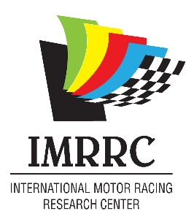

IMRRC 2026 Membership
Members: Benefactors:
  - Student Membership ($15.00) Redline ($1000.00)
  - Paddock ($30.00) Podium ($2,500.00)
  - Starting Grid ($60.00) Checkered Flag ($5,000)
  - Pole Position ($125.00)
  - Green Flag ($250.00)
  - Ignition/Family ($500.00
Name: __________________________________ Phone: ___________________
Address: ___________________________________________________________
City: __________________________ State: ______________ Zip: _____________
Email: ____________________________________________________________
Please make all checks payable to IMRRC. Mail to: 610 South Decatur Street, Watkins Glen, NY 14891
Circle One: Check Enclosed / VISA/ Mastercard/ American Express/ Discover
Card #: _____________________________ CVV: _______
Exp. Date: __________ Billing Zip: ________________
The IMRRC is a 501© (3) charitable organization. Your contribution may have tax benefits.

You can e-mail this form to Hdoll@racingarchives.org or print and mail to the IMRRC: 610 South Decatur Street, Watkins Glen, New York 14891.

