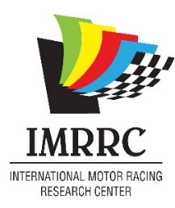

IMRRC 2026 Business Membership Application
Business/ Corporate Memberships include: event space discounts at The IMRRC headquarters (610 South Decatur Street, Watkins Glen, NY, six free admissions to the 2026 Michael R. Argetsinger Symposium (November 12-13, 2026), and opportunities for cross-promotion on IMRRC social media platforms.
Business/College/ Corporate Name: __________________________________
Address: ___________________________________________________________
City: _________________________ State: _________________ Zip: _________
Country: ___________________ Phone: ________________________________
Membership Contact:
Name: _______________________________ Email: _______________________
Phone: ______________________________ Role: _________________________
Billing Contact:
Name: _________________________ Email: ___________________________
Number of Employees:
- 1-50 Employees ($500.00)
- 50-100 Employees ($1000.00)
- Over 100 Employees ($2500.00)
Billing Information:
Circle One: Check Enclosed / VISA/ Mastercard/ American Express/ Discover
Please make all checks payable to IMRRC. Mail to: 610 South Decatur Street, Watkins Glen, NY 14891
Card #: _____________________________ CVV: _______
Exp. Date: __________ Billing Zip: ________________
The IMRRC is a 501© (3) charitable organization. Your contribution may have tax benefits.
You can e-mail this form to Hdoll@racingarchives.org or print and mail to the IMRRC: 610 South Decatur Street, Watkins Glen, New York 14891.

